**Determine if the survival rate is associated to the class of passenger**

Variable Definition Key

survival -- Survival 0 = No, 1 = Yes

pclass -- Ticket class 1 = 1st, 2 = 2nd, 3 = 3rd

Chi-square statistic: 102.88898875696056

P-value: 4.549251711298793e-23

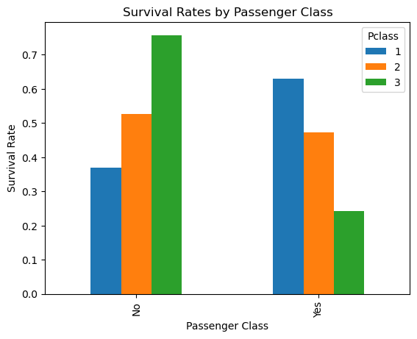

The p-value is less than our chosen significance level (e.g. 0.05), we can reject the null hypothesis and conclude that there is a significant association between survival rate and passenger class. If the p-value is greater than our chosen significance level, we fail to reject the null hypothesis and cannot conclude that there is an association between survival rate and passenger class.

**Determine if the survival rate is associated to the gender**

Variable Definition Key

survival -- Survival 0 = No, 1 = Yes

Chi-square statistic: 260.71702016732104

p-value: 1.1973570627755645e-58

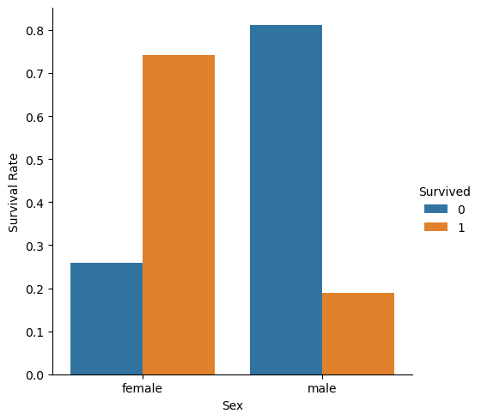

The p-value is less than 0.05 (assuming a significance level of 0.05), we can reject the null hypothesis that gender and survival are independent and conclude that there is an association between the two variables.

### Determine the survival rate is associated to the age

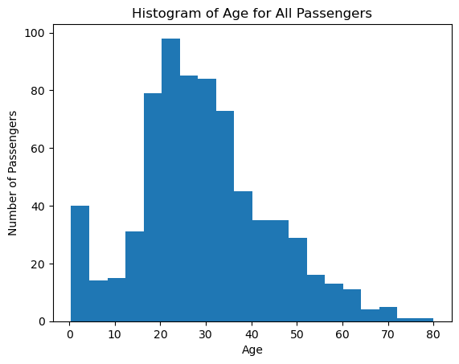

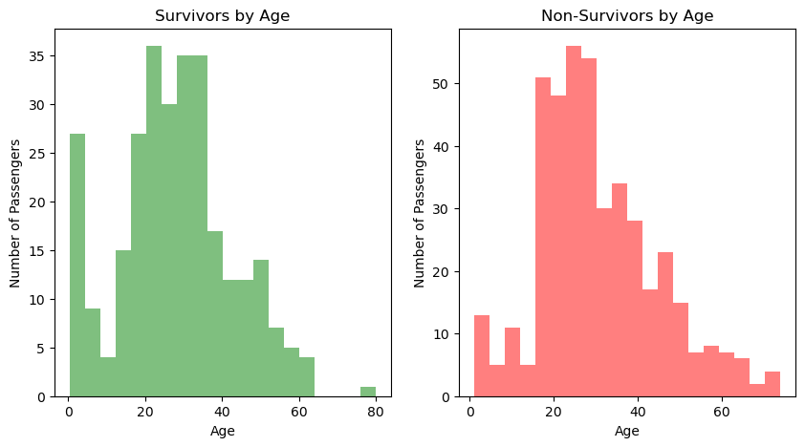

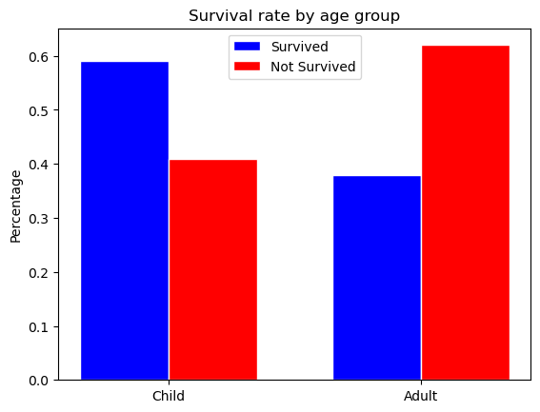

Chi-squared statistic: 7.35845688661176

P-value: 0.061309035112460046

The chi-squared statistic for this test is 7.35845688661176, and the p-value is 0.061309035112460046. Since the p-value is greater than the standard significance level of 0.05, we fail to reject the null hypothesis. Therefore, there is insufficient evidence to conclude that there is an association between survival rate and age among all subjects in the population.